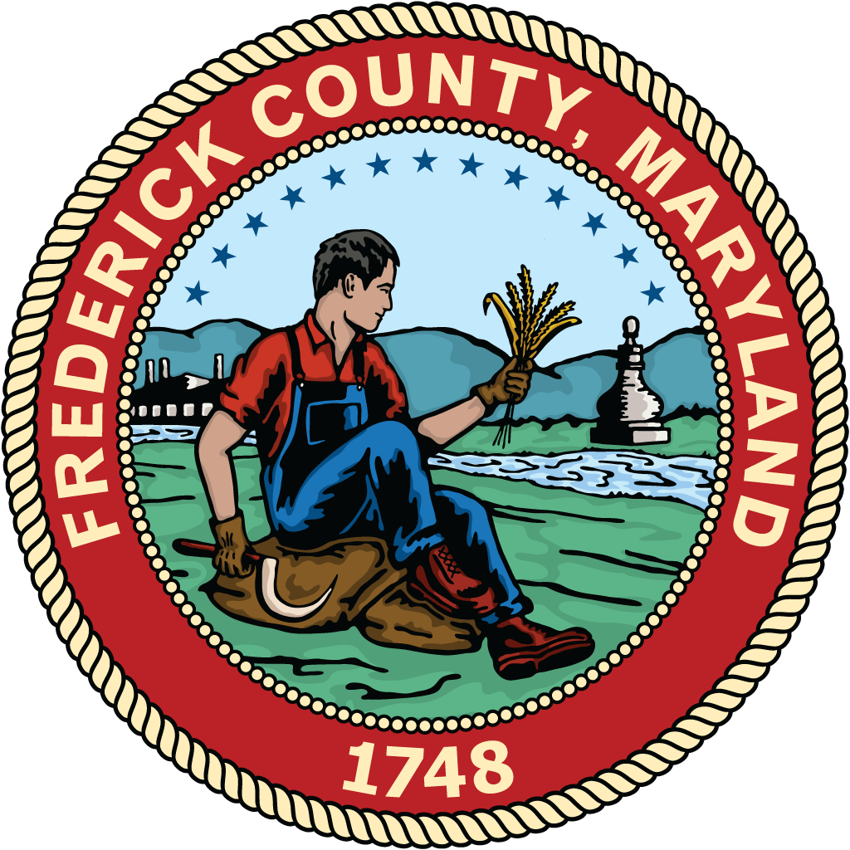
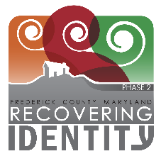
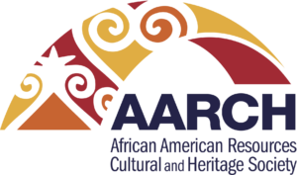
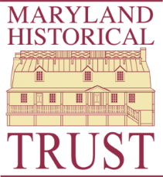

News Release

FOR IMMEDIATE RELEASE CONTACT: Beau Lockard
SEPTEMBER 20, 2023 Historic Preservation Planner
301-600-1149

County to Host Community Meeting to Launch Countywide Historic Context Study

Frederick, Md. – African American Resources Cultural and Heritage Society (AARCH Society) and Frederick County will host the first community meeting to launch a countywide historic context study about African American places on September 27, 2023 at 7 p.m. at the Rollins Life Celebration Center located at 330 Catoctin Ave in Frederick.
The meeting is open to anyone interested in learning about historic context studies, African American history, or how to get involved with the project. They will share why historic context studies are important for community planning, an overview of the goals and purpose for this study, oral histories, and ongoing efforts to preserve Frederick County’s African American history.
Additionally, AARCH Society and Frederick County are seeking community involvement and public comment from those with personal experiences and knowledge of the County to ensure accurate and complete documentation of Frederick County’s African American history.
The countywide historic context study is Phase II of the Recovering Identity project to study African American history and sites throughout Frederick County. Phase I, completed by Catoctin Furnace Historical Society (CFHS), produced a context statement and surveyed African American sites in northern Frederick County. Both phases are funded in part by the Maryland Historical Trust’s Non-Capital Survey Grant.
AARCH Society and the County will hold more public meetings throughout Phase II. For more information about Recovering Identity, please contact County staff at RecoveringIdentity@FrederickCountyMD.gov.

###

African American Resources Cultural and Heritage Society (AARCH Society) identifies, collects, preserves, and makes publicly accessible through our programs and services the objects, artifacts, and stories about the history, rich heritage and culture and the contributions of African Americans in Frederick County past and present and in doing so educates, enriches, and enlightens this and future generations.
Frederick County Livable Frederick Planning and Design Office is the long range, comprehensive planning department within Frederick County using the Livable Frederick Master Plan, a vision-based strategic plan for Frederick County’s long-term future well-being.
Maryland Historical Trust (MHT) is the state agency dedicated to preserving and interpreting the legacy of Maryland’s past. Through research, conservation and education, the Maryland Historical Trust assists the people of Maryland in understanding their historical and cultural heritage.

